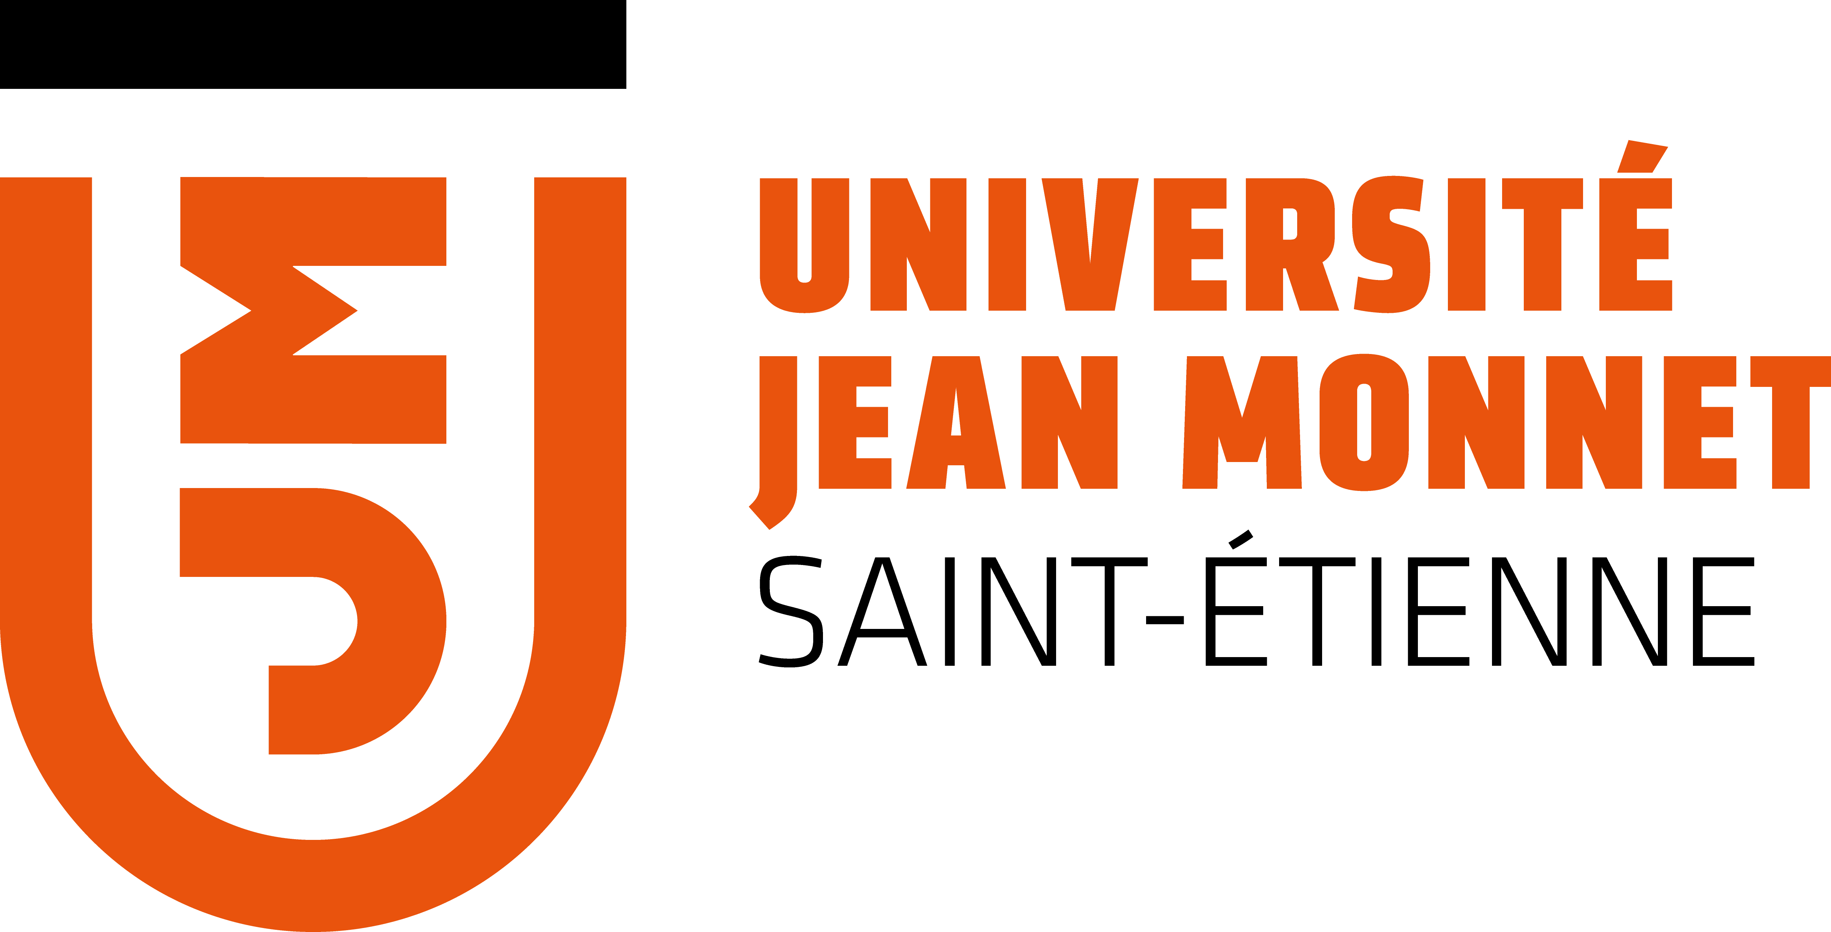



1st year - International Master of Bioacoustics MoBi M1

Projected Fees: 750 €

2026-2027 admission form

First name
Last Name
Birthdate
Country of birth
Country of citizenship
Gender
Permanent address
number/street/ city/state/zip/ country
Email
Phone number
ID/Passport No
Language(s) | French YES NO English YES NO
Highest qualification
Current occupation
Are you a student registered at the Universities of Lyon or Saint-Etienne? | YES NO  If YES, please specify:
COVER LETTER
Please introduce yourself and explain your motivations to take the MoBi M1 course.

Contact information of two academic referees:
Referee 1
Name
Position
Institution
Email address
Referee 2
Name
Position
Institution
Email address

Please read the confirmations below and check the corresponding box.
I confirm that I have a sufficient level to follow classes and complete assessments in French AND English:

I confirm that I understand that a basic level in signal physics and Python programming is required and that it is my responsibility to acquire these abilities BEFORE the course starts:
I confirm that I have understood the following: The first semester of the MoBi M1 program takes place at the University of Saint-Étienne, while the second semester takes place at the University of Toulon. I will therefore need to move (at my own expense) between the two semesters (end of January):
I have understood that I am responsible for arranging and paying for my own accommodation in both locations (Saint-Etienne and Toulon):
I understand that my admission to the 2nd year of the MOBI Master's programme is guaranteed provided that I successfully pass the first-year examinations (minimum average grade of 10/20):
If I continue into the MoBi M2 programme next year, I confirm my commitment to pay the required registration fees (projected fees for MoBi M2: €1,500):
If my application is successful, I understand that my enrolment in MoBi M1 will only be finalised once I have paid the full registration fees (projected fees: 750 €, which includes master fees + university diploma in Bioacoustics):
Applicant’s signature

Please return this form + a short CV (2 pages max) to

emmanuelle.combe@univ-st-etienne.fr before April 30th, 2026.

+ in parallel with sending this form, it is essential to submit a complete application file on the MON MASTER website (without this, your application will not be considered): https://monmaster.gouv.fr/formation/0422388T/2200117CR5KE/detail.

Accepted candidates will be notified before July 15th 2026.

